**Step-1:** open vivado tool.

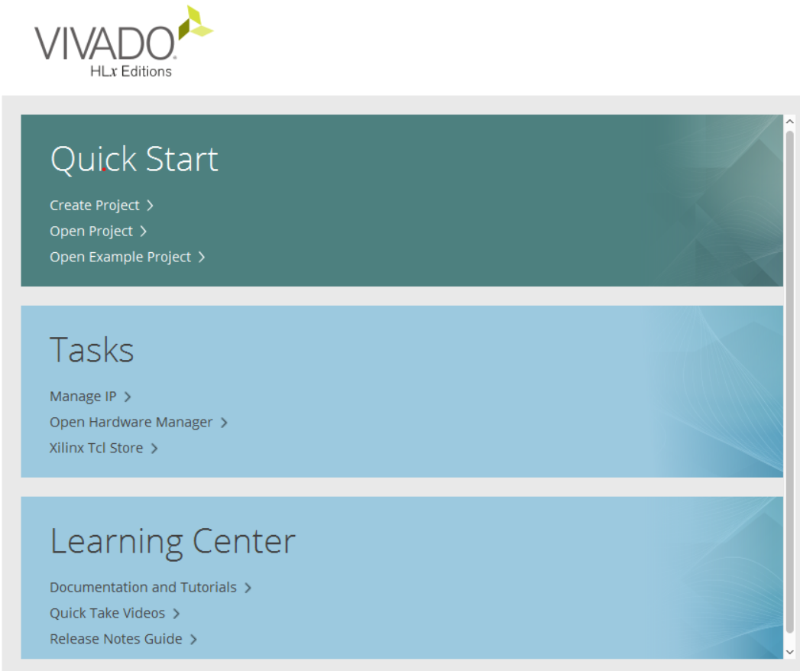

**Step-2:** Click on create project for creating a new project, click next.

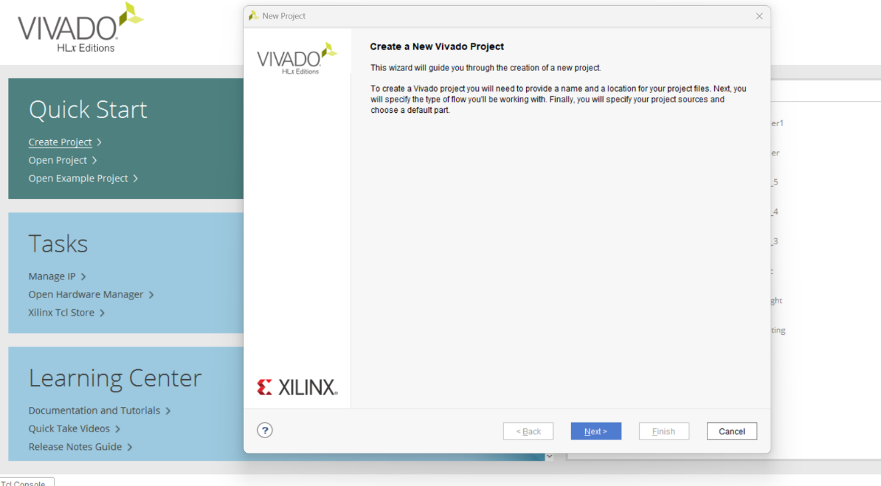

**Step-3:** Give a project name and select the project location then click next.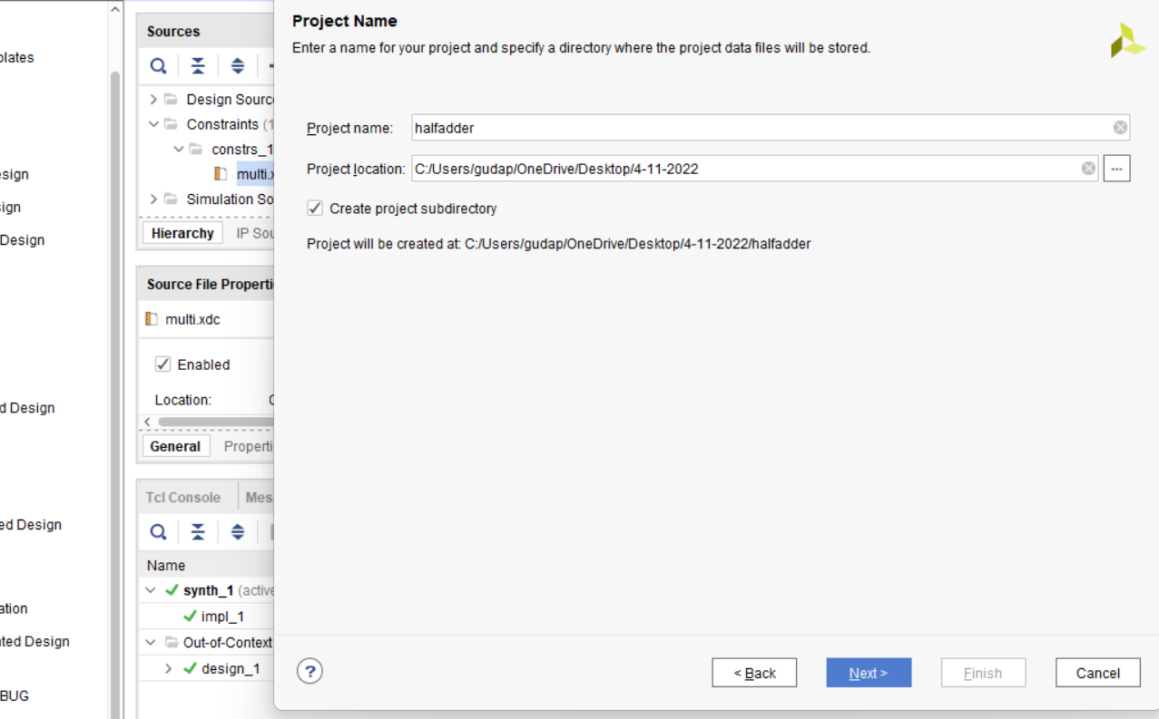

**Step-4:** Now select RTL project, then click next.

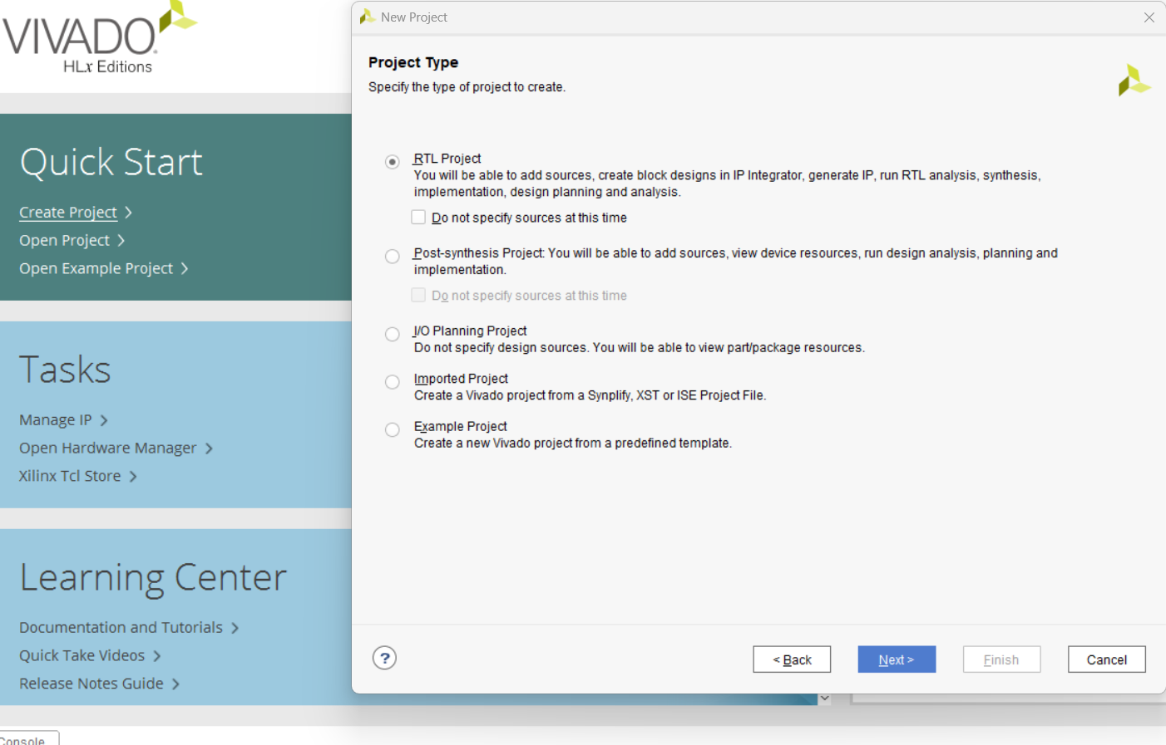

**Step-5:** we can create a design file here but I didn’t create a file here so click next.

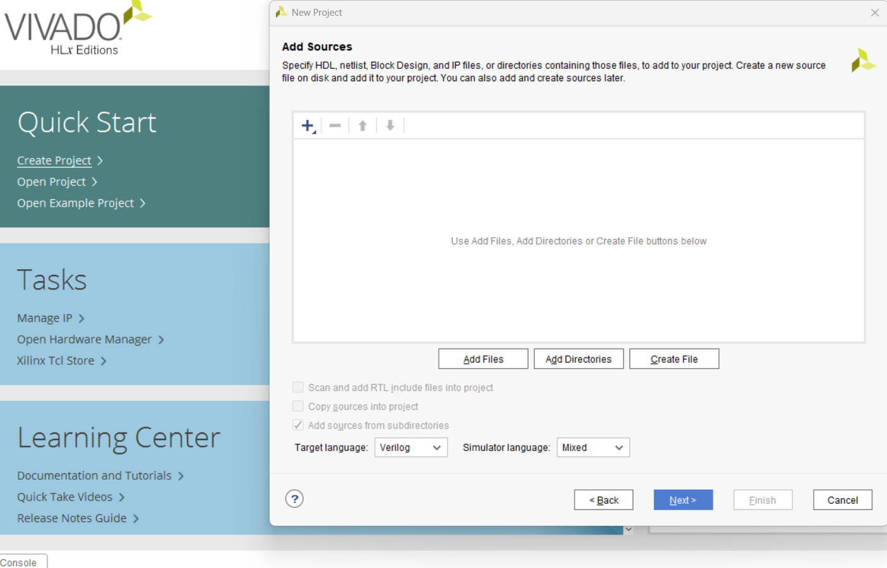

**Step-6:** Here also I didn’t add any constraint sources so click next.

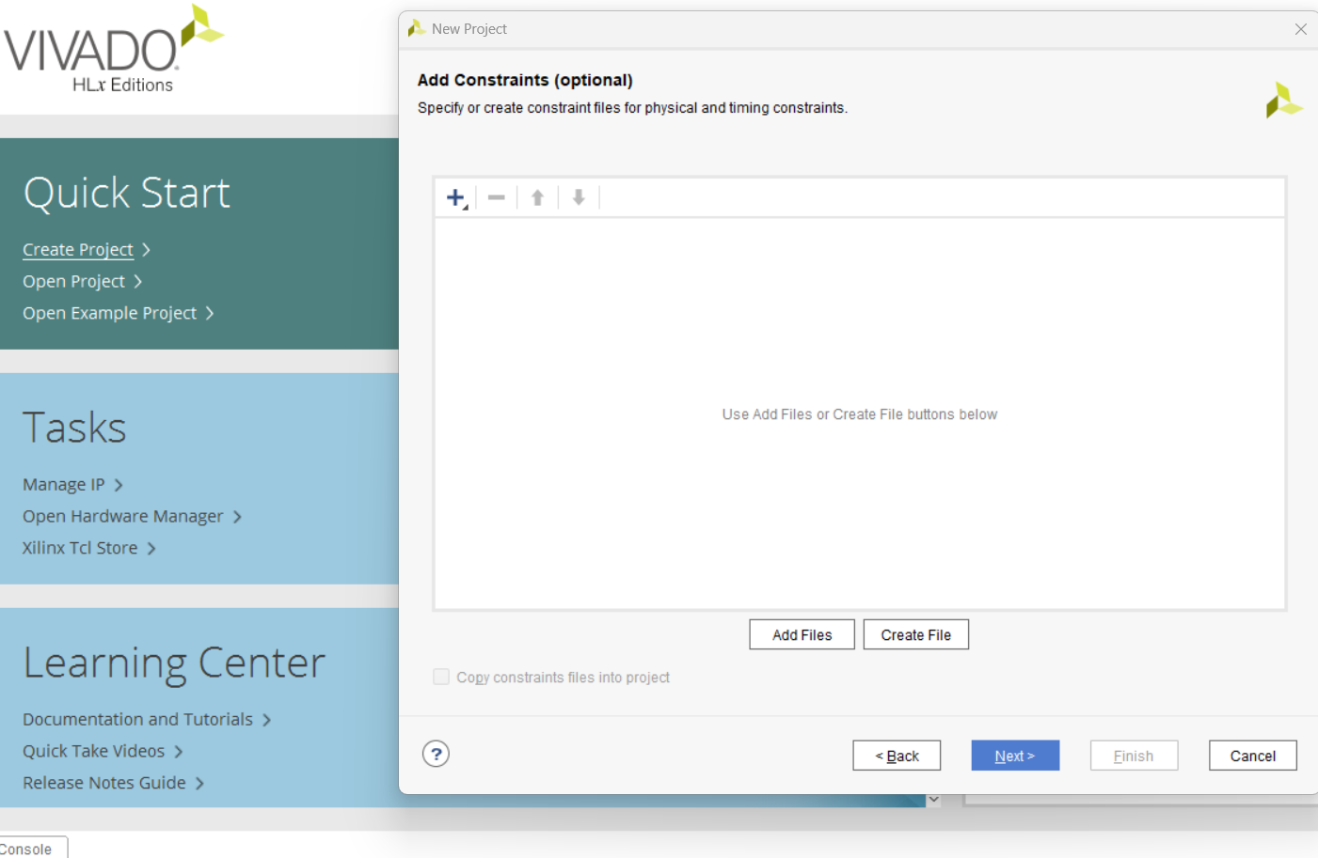

**Step-7:** select the ZYNQ 702 board, part is **xc7z020clg484-1.**

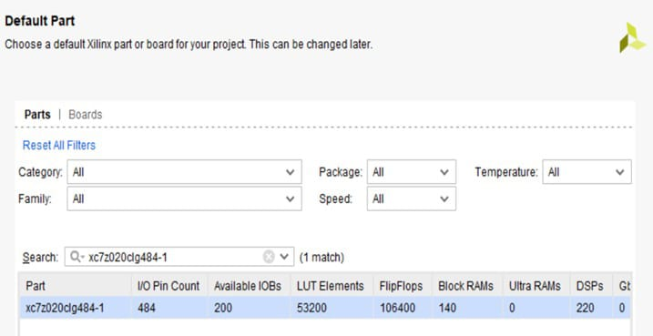**Step-8:** Click Finish

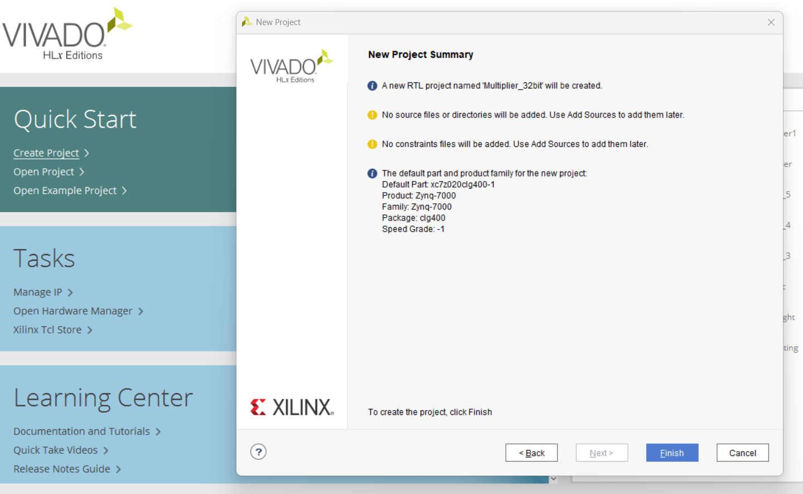

**Step-9:** After creating the project the work directory is looks like this.

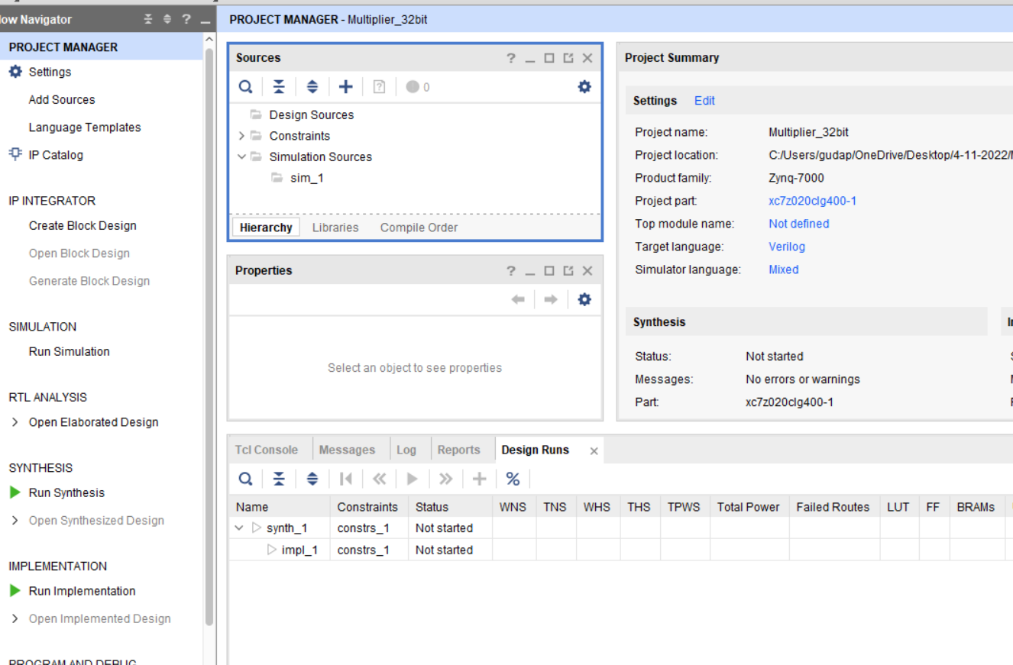

**Step-10:** Here we have seen sources, Right click on design source, click add sources.

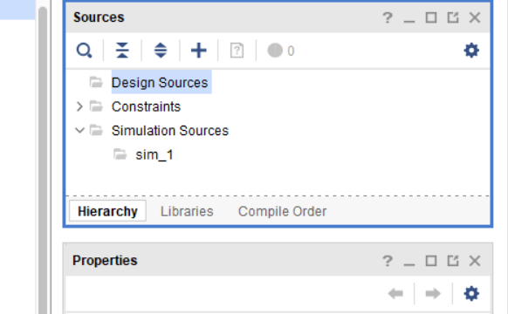

**Step-11:** select the Add or create design sources and then click next.

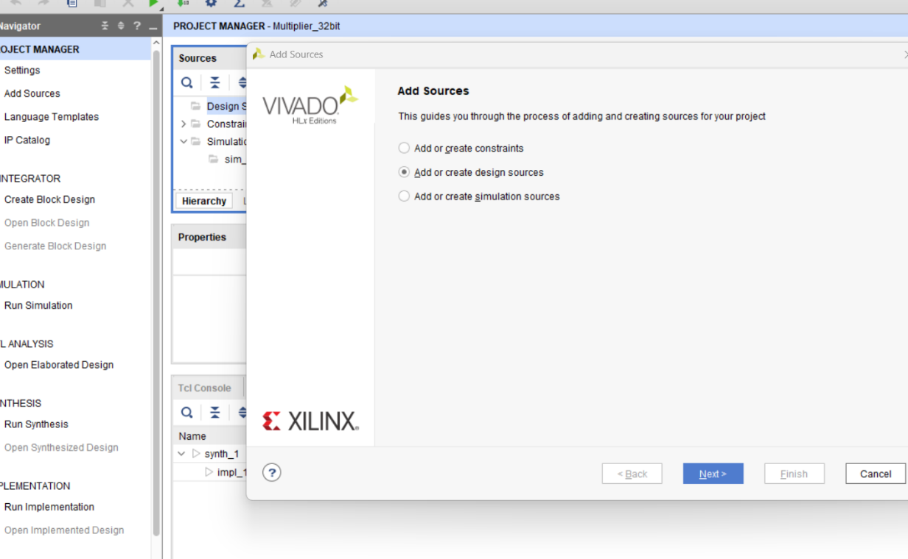

**Step-12:** click on create file.

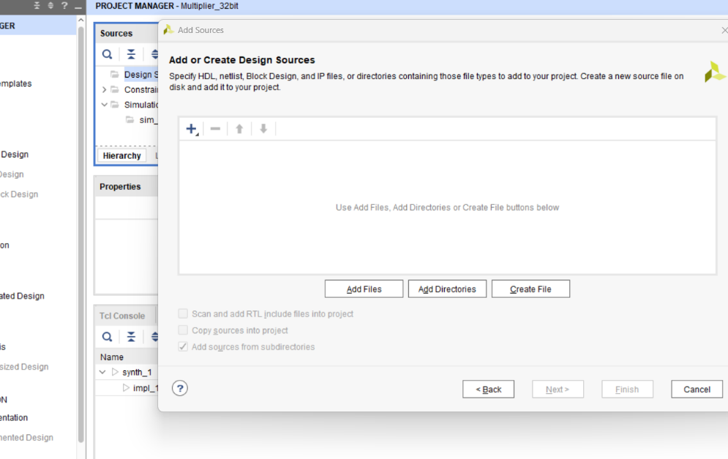

**Step-13:** Give the file name and choose the location then click ok and click Finish.

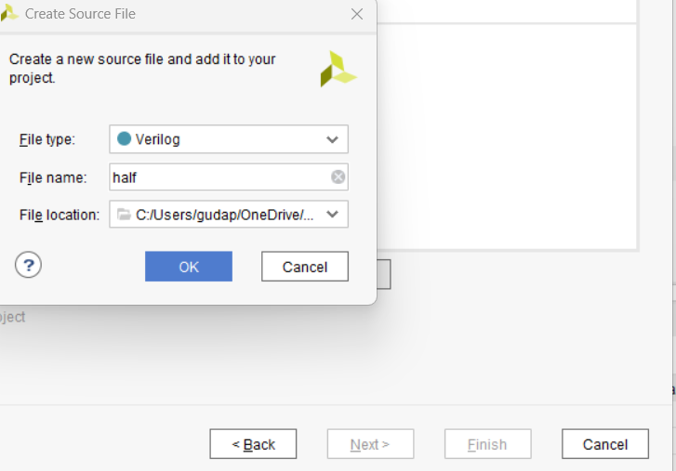

**Step-14:** Now write a half adder code in Verilog.

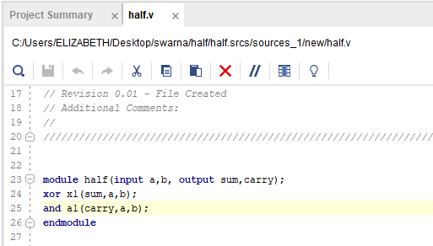

**Step-15:** click on Run Simulation

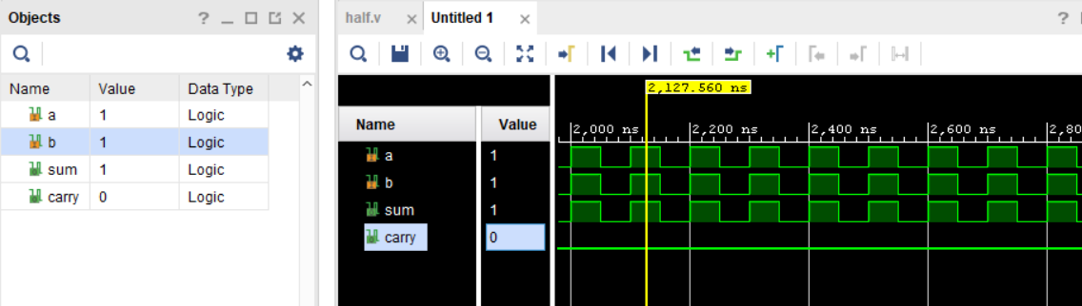

**Step-16:** click on Run synthesis, click ok.



**Step-17:** Right side of corner it will be synthesize.

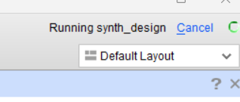

**Step-18:** click on Run implementation, click ok , and click ok again.

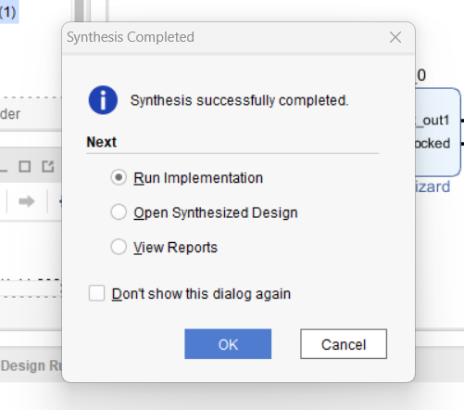

**Step-19** here upside of the right corner the design is implementing.

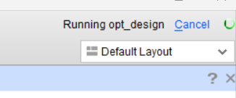

**Step-20:** click ok.

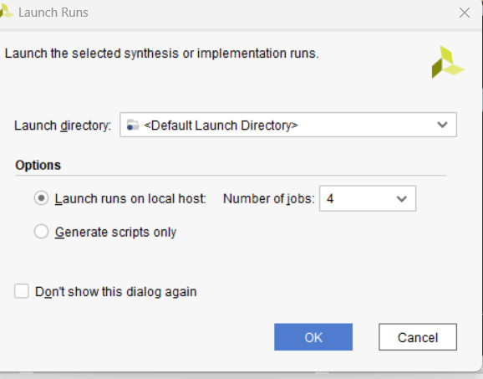

**Step-21:** Give the pins to inputs and outputs.

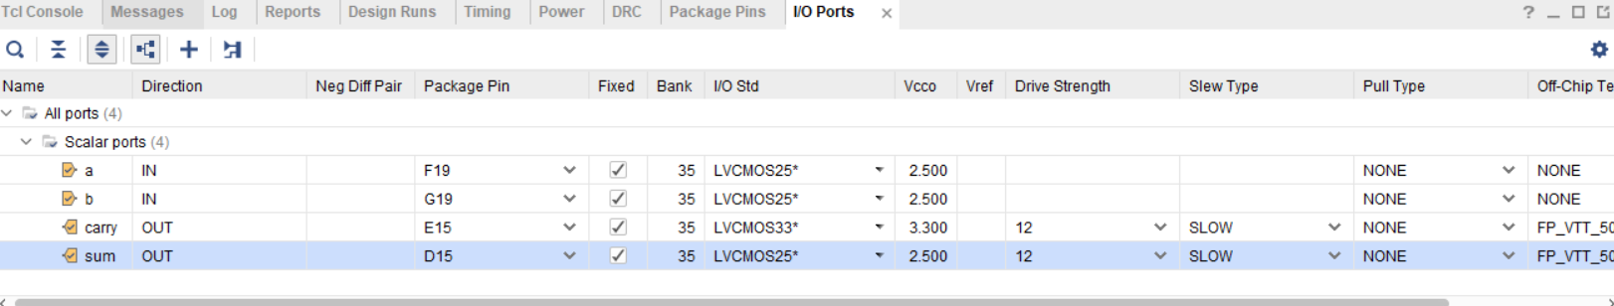

**Step-22**: save the pin planning and open the constraints file.

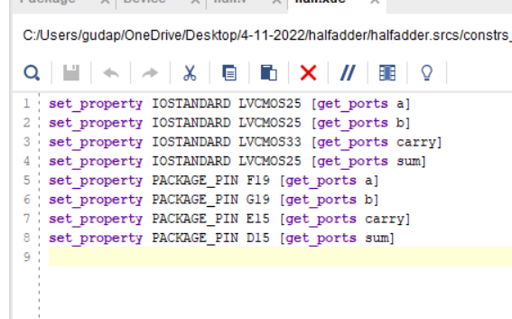

**Step-23:** Now generate the bitstream file.



**Step-24:** click ok.

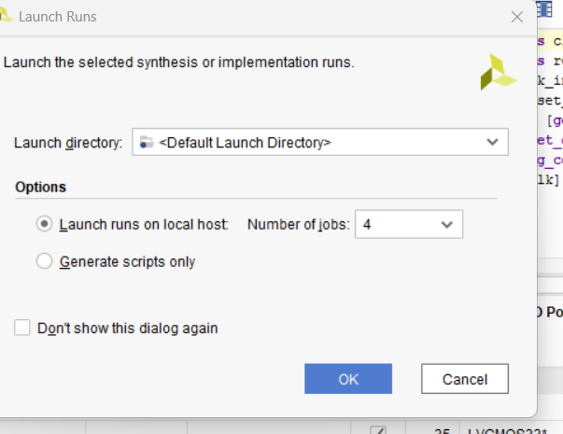

**Step-25:** Open Hardware Manager and click ok.

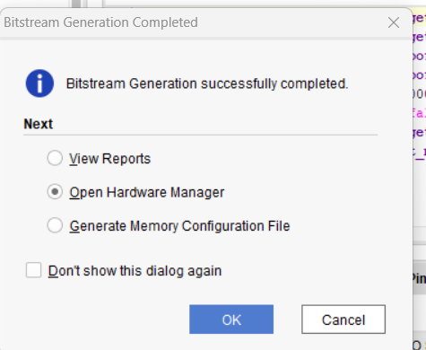

**Step-26:** Now connect the ZYNQ 702 board to system through USB cable. Click on open target.

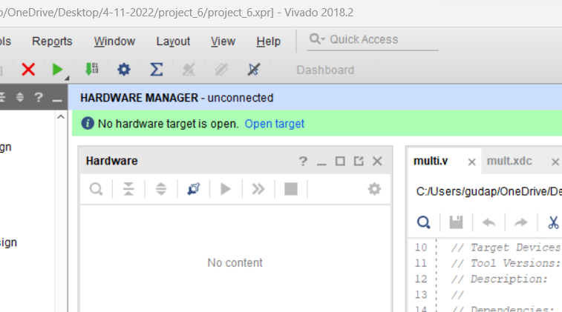

**Step-27:** Click on Auto connect, select the board, dump the program on board and click on program.

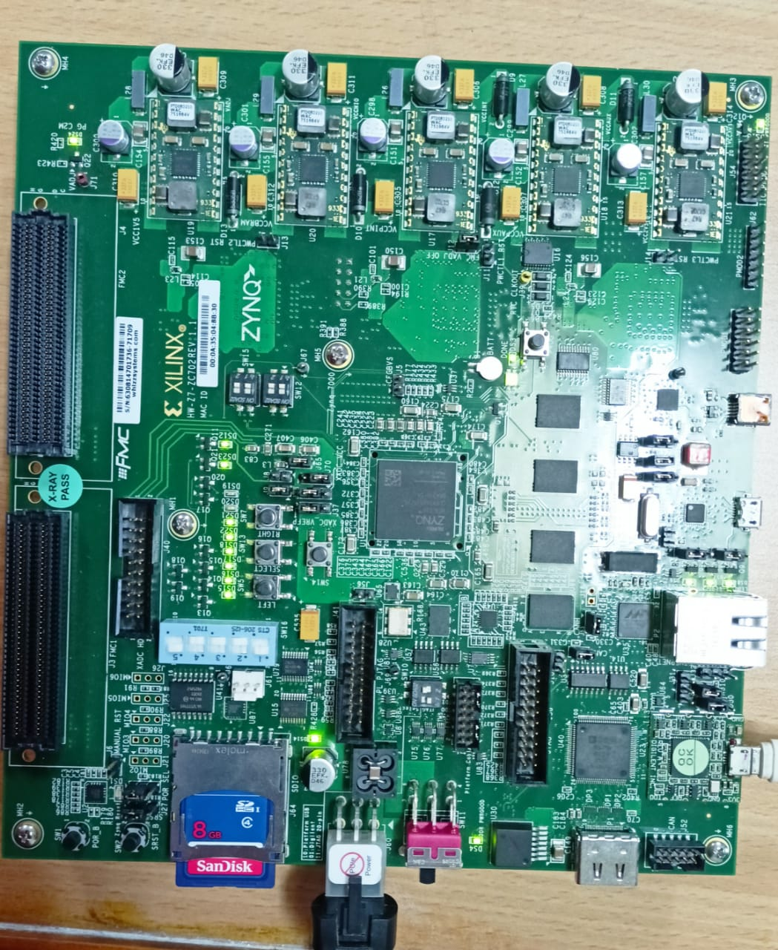

**Step-28:** give the binary inputs and check the outputs on ZYNQ 702 board.